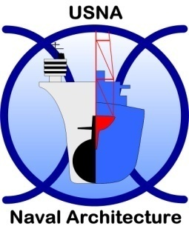
United States Naval Academy

FACULTY POSITION IN
NAVAL ARCHITECTURE

The Naval Architecture and Ocean Engineering Department at the United States Naval Academy invites applications for a full-time, tenure-track faculty position in the Naval Architecture Program starting in August 2011. The Naval Academy is an undergraduate institution dedicated to teaching excellence. The Naval Architecture major emphasizes project-based learning in an intensive, ABET-accredited curriculum. We seek candidates who will contribute to a broad field of study, including hydrostatics, ship design, resistance and propulsion, hydrodynamics and ship production. Of special interest are qualifications that could support our design curriculum. Class sizes are small and laboratories are generously equipped, including a 380-foot towing tank. In addition to teaching, the successful candidate is expected to publish scholarly work, play a significant role in advising students, and provide service to the Academy and the wider professional community. Excellent opportunities exist for collaboration with faculty within the department as well as nearby research organizations.

Preference will be given to candidates at the Assistant Professor level. Applicants must have an earned doctorate in Naval Architecture and Marine Engineering or a closely-related field. A PE in naval architecture or a related field and experience working in a ship or small craft design office is highly desired. U.S. citizens or permanent residents are preferred. The Naval Academy is an equal opportunity affirmative action employer, and provides reasonable accommodation to qualified applicants with disabilities.
Applicants should submit a detailed C.V., a statement of their teaching and research interests, and names of three professional references. Applications, nominations and inquiries should be sent via email to: enasearch@usna.edu, c/o ENA Search Committee, Department of Naval Architecture and Ocean Engineering, 410-293-6420. For more information about the Academy and our program see our web page: www.usna.edu. Application review will begin on 1 April 2011 and continue until the position is filled.

